Digital Delivery Management Accreditation Handbook
22 April 2022

TABLE OF CONTENT

1.0 About buildingSMART Singapore 3
2.0 About the Accreditation Scheme 4
2.1 Digital Delivery Management Assistant Specialist (Tier 4) 4
2.2 Digital Delivery Management Specialist (Tier 3) 5
2.3 Digital Delivery Management Lead (Tier 2) 5
2.4 Chief Digital Officer (Tier 1) 5
2.5 Moving up the Tiers 6
3.0 Accreditation Framework 7
3.1 Mode of Assessment of Skills and Competency 7
3.1 The Logbook 7
3.2 Assessment Test 8
3.3 Case Study (Submitted on Appeal) 9
3.4 Appeal 9
4.0 Accreditation Criteria 10
4.1 Technical Skills and Competencies (TSC) 10
4.2 Key Tasks 11
4.3 Critical Core Skills 11
5.0 Code of Conduct 11
Accredited personnel shall: 11
6.0 The People 12
6.1 Accreditation Committee 12
6.2 Appeal Committee 12
6.3 Assessment Committee 12
6.4 Disciplinary Committee 12
7.0 Administration of Scheme 13
7.1 Application Process 13
7.2 Appeals Process 14
7.3 Feedback Channels 14
7.4 Fee Structure 14
7.5 Accreditation Renewal 15

1.0 About buildingSMART Singapore
bSS is an open, neutral, not-for-profit organization. We are committed to delivering improvement by the creation and adoption of open standards and solutions for infrastructure and buildings.

Singapore’s built environment sector will benefit greatly from a digital spine built around interoperable systems. Our mission has always been to maintain interoperable, open standards in BIM that transcend traditional design and construction phases to enable a comprehensive digital environment for the entire project and asset lifecycle. We aim to get the entire construction value chain consisting of contractors, developers, architects, and landscapers to be on board with Singapore’s digital adoption strategy.

Internationally, bSS is backed by a community of BIM professionals through our affiliation with buildingSMART International (bSI), a worldwide industry body driving digital transformation of the built asset industry. bSI has an ongoing professional certification programme which enables learning organisations around the world to educate and certify BIM professionals according to a recognised global framework.

Locally, members of BSS are from the main TACs, GPEs, IHLs, as well as prominent vendors in the industry. This scheme has broad industry representation and support.

The main objective of the Skills Framework is to re-frame employers’ view of employability to focus on skills and experience. As the Accreditation Body, bSS encourages employers to seek evidence of a candidate’s knowledge and abilities when making a decision to hire or promote. Information regarding this Accreditation Scheme will be published on the bSS website, so that employers are aware of the scope of accreditation. The TSCs not assessed under this Accreditation Scheme should be assessed by employers when making HR decisions.

2.0 About the Accreditation Scheme
bSS is the Accreditation Body for the Digital Delivery Management track of the Built Environment Skills Framework. The Skills Framework allows professionals within this track to structure their career for progression. As the Accreditation Body, bSS recognizes the candidate’s skills, knowledge and experience gained to help him/her rise through the ranks and/or negotiate for pay increments within his/her organization.

Currently, bSS provides a scheme to accredit the Specialist (Tier 3) and Lead (2) positions. bSS will accredit the Assistant Specialist (Tier 4) and Chief Digital Officer (Tier 1) by 2nd quarter of 2022. Membership with bSS is not a pre-requisite for accreditation.

The following table illustrate the job roles and career pathways within the Built Environment.

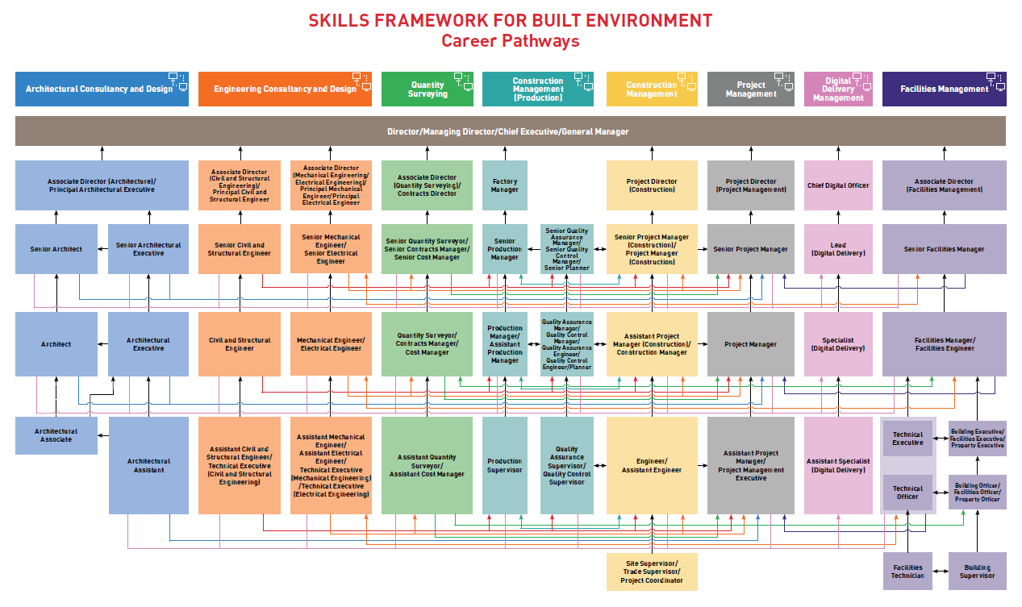

2.1 Digital Delivery Management Assistant Specialist (Tier 4)

The Assistant Specialist (Digital Delivery) assists in project delivery, development and adoption of digital solutions and competency building. He/She participates in product and model development, planning, research and/or testing of digital solutions and training. He gathers data and information to understand business needs and user requirements to support adoption and implementation of digital and/or automated building solutions and resolves issues.
He is a team player and possesses strong communication skills to interact with relevant stakeholders and subject matter experts. He is also resourceful and able to collate information required to develop digital solutions. He works in a fast-paced environment and may be required to work both on- and off-site.

2.2 Digital Delivery Management Specialist (Tier 3)

The Specialist (Digital Delivery) is involved in project delivery, digital solutions development and adoption and competency building. He/She interprets business requirements and helps to translate them into digital solutions. He is familiar with digital solutions and business requirements to add value to the business. He provides timely and value-added services to end-user digital solutions. He ensures that the quality of information and models prepared by the specialists adhere to the prescribed standards and protocol for sharing and coordination purposes. He is also involved in training.

He is independent and possesses strong problem-solving skills. He keeps abreast with new digital technologies and is keen to experiment and adopt new digital solutions to enhance project outcomes. He works in a fast-paced environment that is highly collaborative with multiple stakeholders.

2.3 Digital Delivery Management Lead (Tier 2)

The Lead (Digital Delivery) plays leading roles in project delivery, digital solutions development and adoption, competency building and innovation. He/She oversees the development and acquisition of digital solutions. He implements policies and processes to support the organisation's strategies. He is responsible for analysing how digital solutions can be used to optimise processes. He is involved in technology adoption, innovation and associated change management activities. He establishes guidelines for the implementation of new solutions and continuous process improvement to drive capability building.

He possesses expertise in digital technologies, is adept in adopting digital solutions to enhance project outcomes and resolve technical challenges. He provides technical guidance and support to his team and is keen to ensure they keep abreast with the latest in digital delivery approaches. He works in a fast-paced environment and manages multiple projects and stakeholders.

2.4 Chief Digital Officer (Tier 1)
The Chief Digital Officer oversees the overall implementation and innovation of digital solutions in the organisation to achieve digital transformation of the business. He/She drives the team to experiment and apply new digital solutions. He leads the strategic direction for his team to ensure efficiency in projects and operations. He drives collaboration within organisation and endorses the work done by the digital team.

He is a leader who defines strategies to champion innovative digital solutions. He is able to anticipate trends and disruptions in the industry to help the organisation prepare. He is able to drive changes within the organisation. He possesses strong persuasive skills to help influence others.

2.5 Moving up the Tiers
To move up each tier, candidates need to meet the Accreditation Criteria, which is to obtain the requisite experience and pass the Skills Assessment. If the candidate is unable to meet the Accreditation Criteria, he/she may submit an appeal along with a case study of their experience. The appeal will be heard by the Appeal Panel on a twice-yearly basis. The result of the appeal will be made known to the candidate within 2 weeks after the appeal interview.

The following table illustrates how professionals within the Built Environment should use the Skills Framework and this Accreditation Scheme to chart their careers.

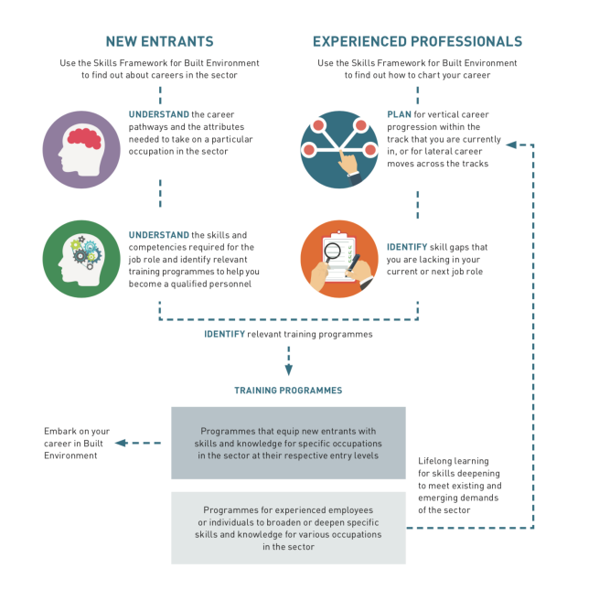

3.0 Accreditation Framework
The DDM accreditation framework prioritizes skills and experience in line with the spirit of the national SkillsFuture movement. This section explains the elements of the DDM Accreditation Framework.

3.1 Mode of Assessment of Skills and Competency

REQUIREMENTS | TIER 2 | TIER 3
Logbook | 75% of Relevant Key Tasks  3 out of 5 Critical Core Skills | 75% of Relevant Key Tasks  3 out of 5 Critical Core Skills
Assessment Test | 8 Core + 10 Elective  Technical Skills & Competencies | 8 Core + 6 Elective  Technical Skills & Competencies
Case Study | Only for appeal cases

3.1 The Logbook
The logbook will be used to assess the applicant’s key tasks and responsibilities and project experience. The project write-up(s), peer reviews and supervisor’s assessment will also add further verification on the applicant’s critical core skills such as communication and digital literacy.

The logbook should list the candidate’s work experience in BIM and IDD projects. There is a validity period of 5 years for projects handled or completed by the applicant to be considered towards accreditation. Each project should have the minimum GFA of not less than 5000sqm to be considered.

The contact details of the candidate’s supervisor and HR Manager shall be listed in the document as the Assessment Committee for the DDM Accreditation Scheme may seek clarification from the supervisor or peers listed in the logbook to request further information or support documentation to verify the competencies of the applicant.

The peer could be the applicant’s supervisor or project team members who had worked on the same project as the applicant and should be of equivalent or higher standing than the applicant (e.g. Project Director).

The logbook must show that the candidate is able to meet 75% of Key Tasks stated in the Skills Map. For Lead accreditation, the candidate is required to produce a BIM or IDD Execution Plan that he/she has authored as part of the documentation submitted.

Requirements | Specialist (Tier 3) | Lead (Tier 2)
Working Experience in BE sector (with qualification) | 2* years (Degree holders)  3* years (Diploma/NITEC) | 4* years (Degree holders)  5* years (Diploma/NITEC)
Working Experience in BE sector (without qualification) | 4* years | 6* years
* Min. 2 years in local context
Projects handled/completed in the last 5 years | 3 BIM/IDD Projects | 5 BIM/IDD Projects (at least 1 IDD Project)
Peer Recommendations | 3 Reviews | 3 Reviews
Evidence of Competency | 75% of Relevant Key Tasks  3 out of 5 Critical Core Skills | 75% of Relevant Key Tasks  3 out of 5 Critical Core Skills

“Without qualification” refers to someone whose academic background is not from the Built Environment.

An administrator will call up the references listed in the logbook for verification. If our administrator finds that the candidate has submitted falsified information in the logbook, he/she will be failed and barred from taking the accreditation.

3.2 Skills Assessment
The Skills Assessment Test a compulsory aspect of the Accreditation Framework. It verifies that the candidate meets the Technical Skills and Competencies as listed on the Skills Map.

Requirements | Specialist (Tier 3) | Lead (Tier 2)
Evidence of Competency | 8 Core + 6 Elective Technical Skills and Competencies | 8 Core + 10 Elective Technical Skills and Competencies

Questions for the Skills Assessment are not software or platform specific as the industry uses different tools for different purposes. The test will focus on the methodologies and applications, rather than the skillsets or competence in the use of a particular software or tool. The Question Bank is created and validated by a team of industry professionals and representatives from Institutes of Higher Learning.

The questions will be primarily based on the Core TSC Modules identified as crucial for a DDM professional to function at the workplace. A short section of the assessment will be based on TSCs which the candidate may elect based on their background.

While the Skills Assessment will be available on a twice-yearly basis, candidates can attempt the Skills Assessment once a year. Candidates who have failed the skills assessment can only take re-take the assessment in the following year.

The Skills Assessment will be held in-person with consideration to social distancing measures in the current COVID-19 climate. The results will be published immediately.

An invigilator will be assigned to run the Skills Assessment to ensure no violation of test conditions. Candidates will be provided a document stating the tasks required to be performed according to our assessment plan and given a standard time to complete, unless he/she has disabilities that require to be considered. The assessment plan will be designed such that our assessor can verify immediately if the candidate has successfully completed the task and demonstrated desired skills. If the candidate is considered “Not Yet Competent”, the assessor will explain the reason for failure, and make recommendations on how to build the skills required.

The assessment questions will be based on the Technical Skills and Competencies (TSCs) as listed in the Skills Map for each position. To pass the Skills Assessment, it is a requirement that the candidate must meet the passing mark requirement of all the Core modules as listed in Section 4.0 (Accreditation Criteria), as well as 50% of the other TSCs listed in the relevant Skill Map.

The candidate will only be allowed to attempt the assessment test if they have been assessed to meet the qualification and logbook requirements. They will not be allowed to attempt the test first and apply for accreditation later.

3.3 Case Study (Submitted on Appeal)
If the candidate is failed based on logbook submission and/or Skills Assessment, he or she may mount an appeal if there are sufficient grounds to do so. The case study is to be presented to the Appeal Panel to make critical observations about the candidate’s ability to function in the accredited job role.

The case study will be helpful for the Appeal Panel in looking at failed applications. By providing additional insight into the candidate’s past work experience and skills, the panel will make a more fine-tuned judgment about the candidate’s ability to be certified as Specialist or Lead.

3.4 Appeal
Candidates that do not meet the Accreditation Criteria will be informed that they have failed the accreditation, and they can appeal this decision if they have sufficient grounds for appeal, which is one of the following scenarios:

- If the applicant has failed a re-test of the Skills Assessment
- If the applicant fulfils the specified no. of projects but one of the projects is marginally smaller than the specified GFA of 5,000 sqm (not more than 10% smaller) or if the applicant’s experience/involvement in the project is not substantial
- If the applicant cannot fulfil the specified no. of projects requirement (i.e. only fulfil 2 out of 3 for Tier 3 or 4 out of 5 for Tier 2) but one of the submitted projects is more than 20,000 sqm and the applicant’s experience/involvement in the project is substantial.

It is the duty of the Appeal Committee to make a judgement to accredit the appellant based on the facts presented via the Case Study and Logbook, as well as the appeal guidelines, to assess if there is ground for a formal change to the candidature.

There will be three panellists reviewing each appeal. At least two out of three panellists on the Appeal Committee must agree to the official decision. At the minimum, one of the panellists shall be of the same discipline as the appellant. For example, if the appellant is a contractor, at least one of the panellist must be from the contractor domain.

The Appeals Committee will review the Case Study and Logbook submitted by the appellant to assess if there is ground for a formal change to the candidature. Only when the appellant is deemed to be worthy of accreditation will he/she be approved to attend the Skills Test.

Appeals will be heard by the Appeal Committee on a twice-yearly basis, following the window period as stated in Section 7.0 (Administration) of this handbook. The result of the appeal shall be announced within 2 months from date of appeal.

4.0 Accreditation Criteria
All candidates must meet 75% of Key Tasks, 50% of Technical Skills and Competencies, and 3 out of 5 Critical Core Skills.

4.1 Technical Skills and Competencies (TSC)
All candidates shall fulfil 50% of the TSCs identified in the Skills Map. This means that Specialist candidates must fulfil 14 TSCs (8 Core TSCs + 6 Elective TSCs); Lead candidates shall fulfil 18 TSCs (8 Core TSCs + 10 Elective TSCs).

Core TSCs

8 Core Technical Skills & Competencies (TSCs) have been identified in consultation with the DDM Workgroup. These are the TSCs which experienced industry professionals have agreed upon that a candidate must meet to perform the job requirement. It is compulsory for all candidates to fulfil the Core TSCs. This is in addition to Elective TSCs.

For DDM Lead (Tier 2): all 8 Core TSCs must be fulfilled

TSC | Level
Building Information Modelling Application | Level 4
Business Process Re-engineering | Level 4
Change Management | Level 5
Common Data Environment Management | Level 4
Emerging Technology Synthesis | Level 5
Integrated Digital Delivery Application | Level 5
Stakeholder Management | Level 5
Technology Application | Level 4

For DDM Specialist (Tier 3): all 8 Core TSCs must be fulfilled

TSC | Level
3D Modelling | Level 3
Building Information Modelling Application | Level 3
Change Management | Level 4
Common Data Environment Management | Level 3
Emerging Technology Synthesis | Level 4
Integrated Digital Delivery Application | Level 4
Stakeholder Management | Level 4
Technology Application | Level 3

Elective TSCs

Elective TSCs consist of the rest of the TSCs as listed in the Skills Map which are not identified as Core. To meet the accreditation criteria, candidates need to fulfil 50% of the TSCs listed in the Skills Map. Candidates can choose to fulfil any of the remaining Elective TSCs up to the number they need to fulfil the accreditation criteria. For Tier 2 (DDM Lead), candidates need to fulfil 10 Elective TSCs. For Tier 3 (DDM Specialist), candidates need to fulfil 6 Elective TSCs. The list of Elective TSCs are listed as follows:

For DDM Lead (Tier 2): 10 TSCs from this list

TSC | Level
3D Modelling | Level 4
Application Support and Enhancement | Level 3
Applications Integration | Level 4
Artificial Intelligence Application | Level 5
Augmented Reality Application | Level 3
Business Development | Level 4
Business Innovation | Level 5
Business Needs Analysis | Level 4
Business Risk Management | Level 4
Construction Technology | Level 3
Continuous Improvement Management | Level 4
Critical Thinking | Level 4
Data Collection and Analysis | Level 5
Design for Manufacturing and Assembly | Level 2
Innovation Management | Level 5
Internet of Things Management | Level 4
Learning and Development | Level 4
Partnership Management | Level 4
People Management | Level 4
Performance Management | Level 5
Programming and Coding | Level 4
Research and Information Synthesis | Level 4
Robotic and Automation Technology Application | Level 4
Strategy Development | Level 4
Systems Integration | Level 4
Systems Thinking | Level 4
Technical Drawing | Level 4
Technology Road Mapping | Level 5

For DDM Specialist (Tier 3): 6 TSCs from this list

TSC | Level
Application Support and Enhancement | Level 2
Applications Integration | Level 3
Augmented Reality Application | Level 2
Business Needs Analysis | Level 3
Business Process Re-engineering | Level 3
Business Risk Management | Level 3
Construction Technology | Level 2
Critical Thinking | Level 3
Data Collection and Analysis | Level 4
Design for Manufacturing and Assembly | Level 2
Innovation Management | Level 4
Learning and Development | Level 3
Partnership Management | Level 3
People Management | Level 3
Performance Management | Level 4
Programming and Coding | Level 3
Research and Information Synthesis | Level 3
Systems Integration | Level 3
Systems Thinking | Level 3
Technical Drawing | Level 3

4.2 Key Tasks
The key tasks are listed as part of the logbook template which the candidate’s workplace supervisor needs to assess. Candidates must meet 75% of the Key Tasks for the accredited job role as listed in the Skills Map.

4.3 Critical Core Skills
The Critical Core Skills are listed as part of the logbook template which the candidate’s workplace supervisor needs to assess. Candidates must meet 3 out of 5 Critical Core Skills for the accredited job role as listed in the Skills Map.

5.0 Code of Conduct
Accredited personnel shall:

- Be ethical and professional in conduct within and outside of the built environment sector
- Uphold and maintain level of competency consistent with the standards as set out in the accreditation scheme
- Discharge responsibilities faithfully with full regard to the employer, client and in the interest of the public
- Uphold confidentiality of former and current employer and client
- Not engage in activities that will undermine his/her professional status or damage the reputation of the profession such as bribery, touting
- Act honourably towards other DDM accredited professionals

bSS reserves the right to suspend or withdraw the accreditation following the advice of the Disciplinary Committee (Section 6.4) in the event of any breach of the expected professional conduct as outlined above after appropriate investigations are completed.

5.1 Disciplinary Procedure
Accredited professionals who are guilty of unsatisfactory conduct or misconduct may be subject to disciplinary action before a Disciplinary Committee.

The Disciplinary Committee may take the following actions after a disciplinary hearing:

- revoke the accreditation
- suspend the accreditation
- admonish or reprimand the accredited person
- attach or vary conditions to the accreditation

6.0 The People
The bSS Accreditation Scheme will be guided by 11 members forming the Accreditation Board. All members on this Board are industry professionals or academics with at least 10 years’ experience in a relevant field or have made major contributions to this field. The Board ensures the governance of the accreditation programme. They will audit the scheme to ensure that it remains fair and representative to the industry. They shall serve on one of the following committees: Appeal Committee, Assessment Committee, or Disciplinary Committee.

6.1 Appeal Committee
The Appeal Committee ensures that worthy candidates who cannot meet the Accreditation Criteria can continue towards accreditation. 3 of the 5 members of the Appeal Committee shall convene at each appeal event to review cases.
When more professionals become accredited, other accredited DDM professionals may be roped in to help with the appeal, on condition that they can only assess one tier downwards. For example, a Tier 2 candidate may only assess the appeal of a Tier 3 candidate.

6.2 Assessment Committee
This team of 5 members sets questions for the Skills Assessment and provides the approval for a candidate’s application for accreditation. To stay on this team, all members must deliver questions for the Question Bank. If the committee member is unable to commit time to meet the requirement, he/she will be released from the team, to keep the Question Bank confidential.

6.3 Disciplinary Committee
Within the Accreditation Board, 1 of the members will be assigned to lead the Disciplinary Committee. When a disciplinary case arises, 2 other members of the Accreditation Board will be roped in to review the case, forming a 3-person panel. The 3-member Disciplinary Committee will assign disciplinary actions following a hearing of alleged unsatisfactory conduct.

7.0 Administration of Scheme
This section provides a detailed breakdown of activities involved in our Accreditation Scheme.

7.1 Application Process
Candidates will submit their application for accreditation to bSS through our website at any time throughout the year. The timeframe from application to result will be processed within 2 months.

If their application meets the Accreditation Criteria (Section 4.0), they will proceed to take the Skills Assessment. If they do not meet the Accreditation Criteria, they will be informed that they cannot proceed with the Accreditation. They may opt to appeal this decision.

The Skills Assessment is open in January and July of each year. The result of the Skills Assessment is immediate. If they pass the Skills Assessment, they achieve accreditation. If they fail the Skills Assessment, they fail the accreditation. They may opt to appeal this decision.

To begin, candidates should go on bSS website to complete an online application form.

The accompanying documents are to be submitted with the application:

  - Recent passport-size photograph
  - Photocopy of Identification Card/Passport
  - Photocopies of certificates for academic qualifications and any other professional qualifications
  - Photocopies of courses attended
  - Logbook (template will be provided) including employment history projects handled, role and responsibilities and tasks performed for projects etc.
  - Sample models/drawings (if applicable)
  - BIM/IDD Execution Plan
  - Reviews from peers

The application is open throughout the year. Candidates will be notified of result within 2 months from date of application.

The Assessment Tests will be conducted 2 times a year.

Once the applicant has met the accreditation criteria, the Accreditation Committee shall provide a final approval for the accreditation.

7.2 Appeals Process
If the candidate is deemed to have failed the criteria based on the information provided in the logbook, he/she may file an appeal if there are sufficient grounds for appeal (per Section 3.4).

The appeal will be heard by an Appeal Panel (reference section 6.2) in March or September of the year, which is designated as the appeal period window.

The appellant will submit a detailed Case Study for use during the appeal. The Appeal Panel can refer to the Logbook, Skills Assessment, and Case Study as the basis for interviewing the candidate. If the panel deems that the candidate should be accredited based on interview, they may approve the appellant’s application and the appellant may proceed to undertake the Skills Assessment. A non-refundable fee of $100 is chargeable.

To begin, the appellant should download the Notice of Appeal template from the bSS website. The appellant shall submit the grounds for appeal using this template. All appeals will be processed within 2 months from the date of appeal. Appeals may only be submitted during the window period as stated in Section 7.6 (Summary of Key Events).

7.3 Feedback Channels
To provide feedback on how we can improve the Accreditation Scheme, please contact us through the bSS website. The feedback will be reviewed by our Accreditation Panel to identify areas for improvement and will be responded to within 7 working days. The feedback will also be collated as a yearly report for the Accreditation Committee.

7.4 Fee Structure
The cost of initial accreditation for locals (Singaporean or Singapore PR) shall be $120 for Specialist Accreditation and $180 for Lead Accreditation (Singapore Dollars). The cost of accreditation for foreigners shall be $250 for either Specialist or Lead Accreditation. Renewal of accreditation on biennial (once per 2 years) basis shall be chargeable at the same rate of initial accreditation.

7.5 Summary of Key Events
The following table summarizes the window period of key events through the year.

Window Period | Event
Throughout the Year | Application
January and July | Skills Assessment
March and September | Appeals

7.6 Accreditation Renewal
The accreditation is valid for a period of 2 years.

Accredited professionals are required to accrue 15 training hours to meet our accreditation renewal requirements every 2 years. This ensures that DDM professionals are always kept up-to-date on the latest available technology and ways of working. Relevant courses counting towards accreditation renewal will be published on the bSS website.

bSS will continually look out for trend updates in the digital delivery track and add to the list of approved courses. bSS will also approach ATOs to encourage them to provide curriculum and content that will lead to DDM accreditation. It is beneficial for ATOs to do so as it adds purpose, direction, and value to their respective training programs.

